## Zucchini Fritters

1. **Origin**: Unknown
2. **Source**: niftyrecipe.com
3. **Category**: Side dish/main dish
4. 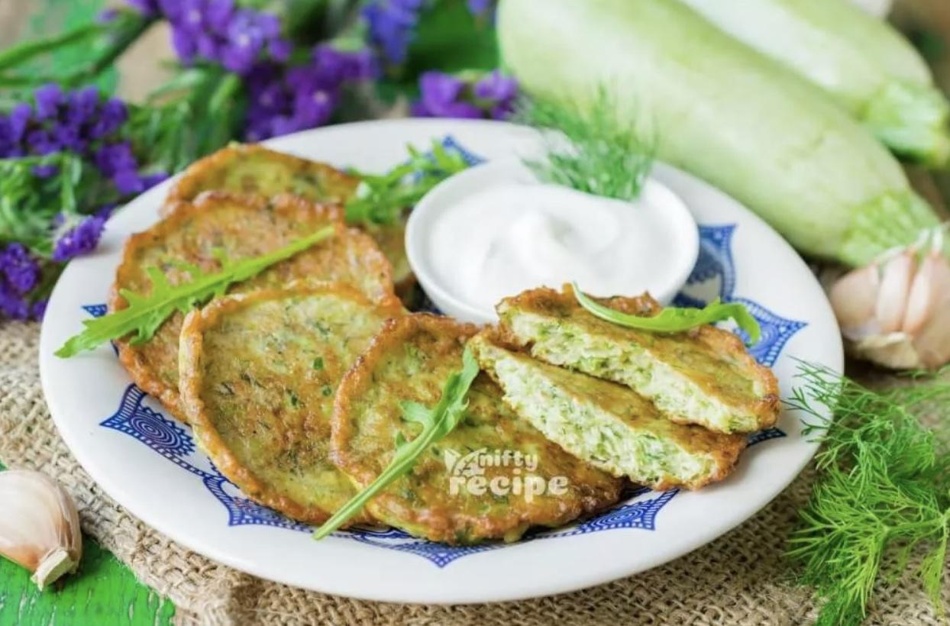
5. Zucchini_fritters_1.jpeg
6. I found this recipe for zucchini fritters on a food blog when I was looking for quick and easy dishes to make during undergrad. It uses minimal ingredients and can be done in less than half an hour. They’re delicious and filling and go great with dipping sauces.
7. **Recipe Ingredients** 
   1. Zucchini
   2. Egg
   3. Flour
   4. Vegetable/seed oil
   5. Garlic
   6. Salt and pepper
8. **Recipe Steps** 
   1. Combine eggs, salt, and pepper and whisk
   2. Add pressed garlic
   3. Grate the zucchini and squeeze the moisture out of it
   4. Add zucchini and flour and mix
   5. Heat oil in pan and add dollops of batter
   6. Serve with or without dipping sauce
9. **Additional Food images**
10. Zucchini_fritters_2.jpeg
11. Grated zucchini.
12. Zucchini_fritters_3.jpeg
13. Ingredients for zucchini fritters combined.
14. Zucchini_fritters_4.jpeg
15. Zucchini fritters in the pan cooking.
16. Kay Malan